Collective Noun

🔹 What is Collective Noun
# Source: AI Source: Provided by: [Data Path: Persons Table -> ID Column: 1, Name_En Column: Motasem Essam] -> From: [Chatgpt (GPT-4-turbo)] on [7/26/2025]
A collective noun is a noun that refers to a group of people, animals, or things considered as a single unit.
✨ Even though it refers to many members, it is treated as one group in grammar.

✅ Definition:
# Source: AI Source: Provided by: [Data Path: Persons Table -> ID Column: 1, Name_En Column: Motasem Essam] -> From: [Chatgpt (GPT-4-turbo)] on [7/26/2025]
A collective noun names a collection or group made up of members, but the noun itself is singular in form.

📚 Common Examples of Collective Nouns:
# Source: AI Source: Provided by: [Data Path: Persons Table -> ID Column: 1, Name_En Column: Motasem Essam] -> From: [Chatgpt (GPT-4-turbo)] on [7/26/2025]
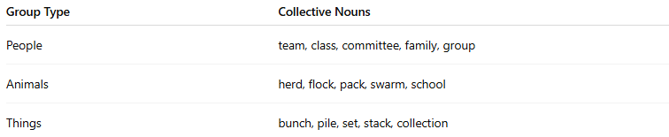
Group Type | Collective Nouns
People | team, class, committee, family, group
Animals | herd, flock, pack, swarm, school
Things | bunch, pile, set, stack, collection

📝 Example Sentences:
# Source: AI Source: Provided by: [Data Path: Persons Table -> ID Column: 1, Name_En Column: Motasem Essam] -> From: [Chatgpt (GPT-4-turbo)] on [7/26/2025]
- The team is practicing for the final match.
- A flock of birds flew overhead.
- The family is going on vacation.
- She bought a set of dishes.
- The committee has made its decision.

🧠 Collective Noun = One Word, Many Members
# Source: AI Source: Provided by: [Data Path: Persons Table -> ID Column: 1, Name_En Column: Motasem Essam] -> From: [Chatgpt (GPT-4-turbo)] on [7/26/2025]
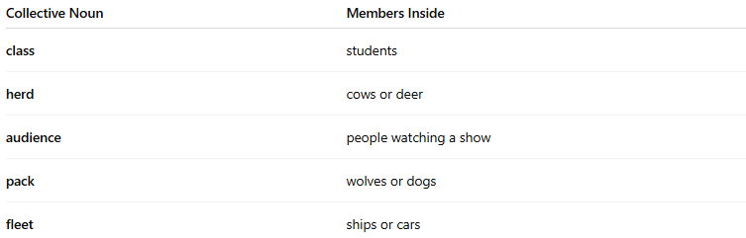
Collective Noun | Members Inside
class | students
herd | cows or deer
audience | people watching a show
pack | wolves or dogs
fleet | ships or cars

⚠️ Grammar Note (Singular vs. Plural Verb):
# Source: AI Source: Provided by: [Data Path: Persons Table -> ID Column: 1, Name_En Column: Motasem Essam] -> From: [Chatgpt (GPT-4-turbo)] on [7/26/2025]
In American English, collective nouns usually take a singular verb:
- ✅ The team is winning.
- ✅ The class has started.
In British English, they often take a plural verb (especially when focusing on individuals):
- ✅ The team are wearing their new uniforms.

📘 Collective Noun vs. Partitive
# Source: AI Source: Provided by: [Data Path: Persons Table -> ID Column: 1, Name_En Column: Motasem Essam] -> From: [Chatgpt (GPT-4-turbo)] on [7/26/2025]
Great question! Let's clearly compare Collective Nouns and Partitives — they both deal with groups or amounts, but in very different ways.

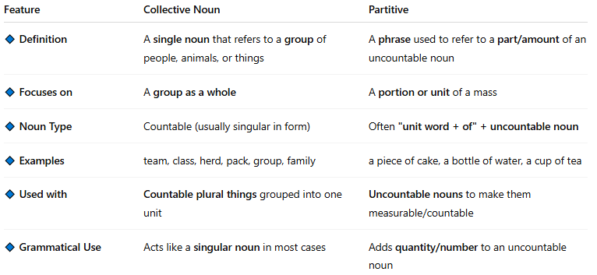
Feature | Collective Noun | Partitive
🔹 Definition | A single noun that refers to a group of people, animals, or things | A phrase used to refer to a part/amount of an uncountable noun
🔹 Focuses on | A group as a whole | A portion or unit of a mass
🔹 Noun Type | Countable (usually singular in form) | Often "unit word + of" + uncountable noun
🔹 Examples | team, class, herd, pack, group, family | a piece of cake, a bottle of water, a cup of tea
🔹 Used with | Countable plural things grouped into one unit | Uncountable nouns to make them measurable/countable
🔹 Grammatical Use | Acts like a singular noun in most cases | Adds quantity/number to an uncountable noun

🧠 In Simple Terms:
# Source: AI Source: Provided by: [Data Path: Persons Table -> ID Column: 1, Name_En Column: Motasem Essam] -> From: [Chatgpt (GPT-4-turbo)] on [7/26/2025]
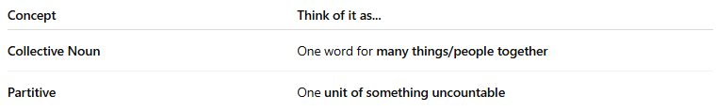
Concept | Think of it as...
Collective Noun | One word for many things/people together
Partitive | One unit of something uncountable

📝 Example Sentences:

✅ Collective Nouns:
# Source: AI Source: Provided by: [Data Path: Persons Table -> ID Column: 1, Name_En Column: Motasem Essam] -> From: [Chatgpt (GPT-4-turbo)] on [7/26/2025]
- The class is taking an exam.
- A flock of birds flew by.
- Our family goes camping every summer.

✅ Partitives:
# Source: AI Source: Provided by: [Data Path: Persons Table -> ID Column: 1, Name_En Column: Motasem Essam] -> From: [Chatgpt (GPT-4-turbo)] on [7/26/2025]
- I drank a glass of water.
- She gave me a piece of advice.
- We ate two slices of cake.

✅ Quick Summary Table:
# Source: AI Source: Provided by: [Data Path: Persons Table -> ID Column: 1, Name_En Column: Motasem Essam] -> From: [Chatgpt (GPT-4-turbo)] on [7/26/2025]
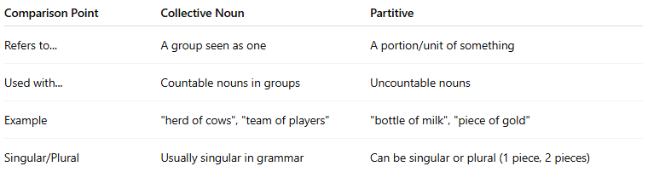
Comparison Point | Collective Noun | Partitive
Refers to... | A group seen as one | A portion/unit of something
Used with... | Countable nouns in groups | Uncountable nouns
Example | "herd of cows", "team of players" | "bottle of milk", "piece of gold"
Singular/Plural | Usually singular in grammar | Can be singular or plural (1 piece, 2 pieces)

✅ Summary:
# Source: AI Source: Provided by: [Data Path: Persons Table -> ID Column: 1, Name_En Column: Motasem Essam] -> From: [Chatgpt (GPT-4-turbo)] on [7/26/2025]

Feature | Collective Noun
Meaning | A group of people/animals/things
Form | Singular noun
Verb agreement | Usually singular (US), sometimes plural (UK)
Examples | family, crowd, bunch, army, pair

